Stopping Distance Experiment

## Introduction:

This experiment will test the relation between the height of a ramp and the distance a cup gets pushed by a marble that rolls down the slope. This will illustrate the stopping power of the cup while being exposed to different forces.

## Hypothesis:

As the height of the slide increases the angle of decent will get steeper and increase the speed of which the marble will roll down the slide and then will pass on more directional energy onto the cup and therefore push the cup further.

## Independent Variable:

The independent variable in this experiment is the angle in which the slip is placed.

## Dependent Variable:

The dependent variable in this experiment is how far the cup is pushed by the marble

## Controlled Variables:

* The slide material
* The marble
* The cup
* Floor material
* Wind
* Environment

## Materials:

* PVC pipe (Slide)
* Marble
* Retort stand
* Vice grips
* Measuring device

## Experiment Plan:

Step 1: Setup test apparatus

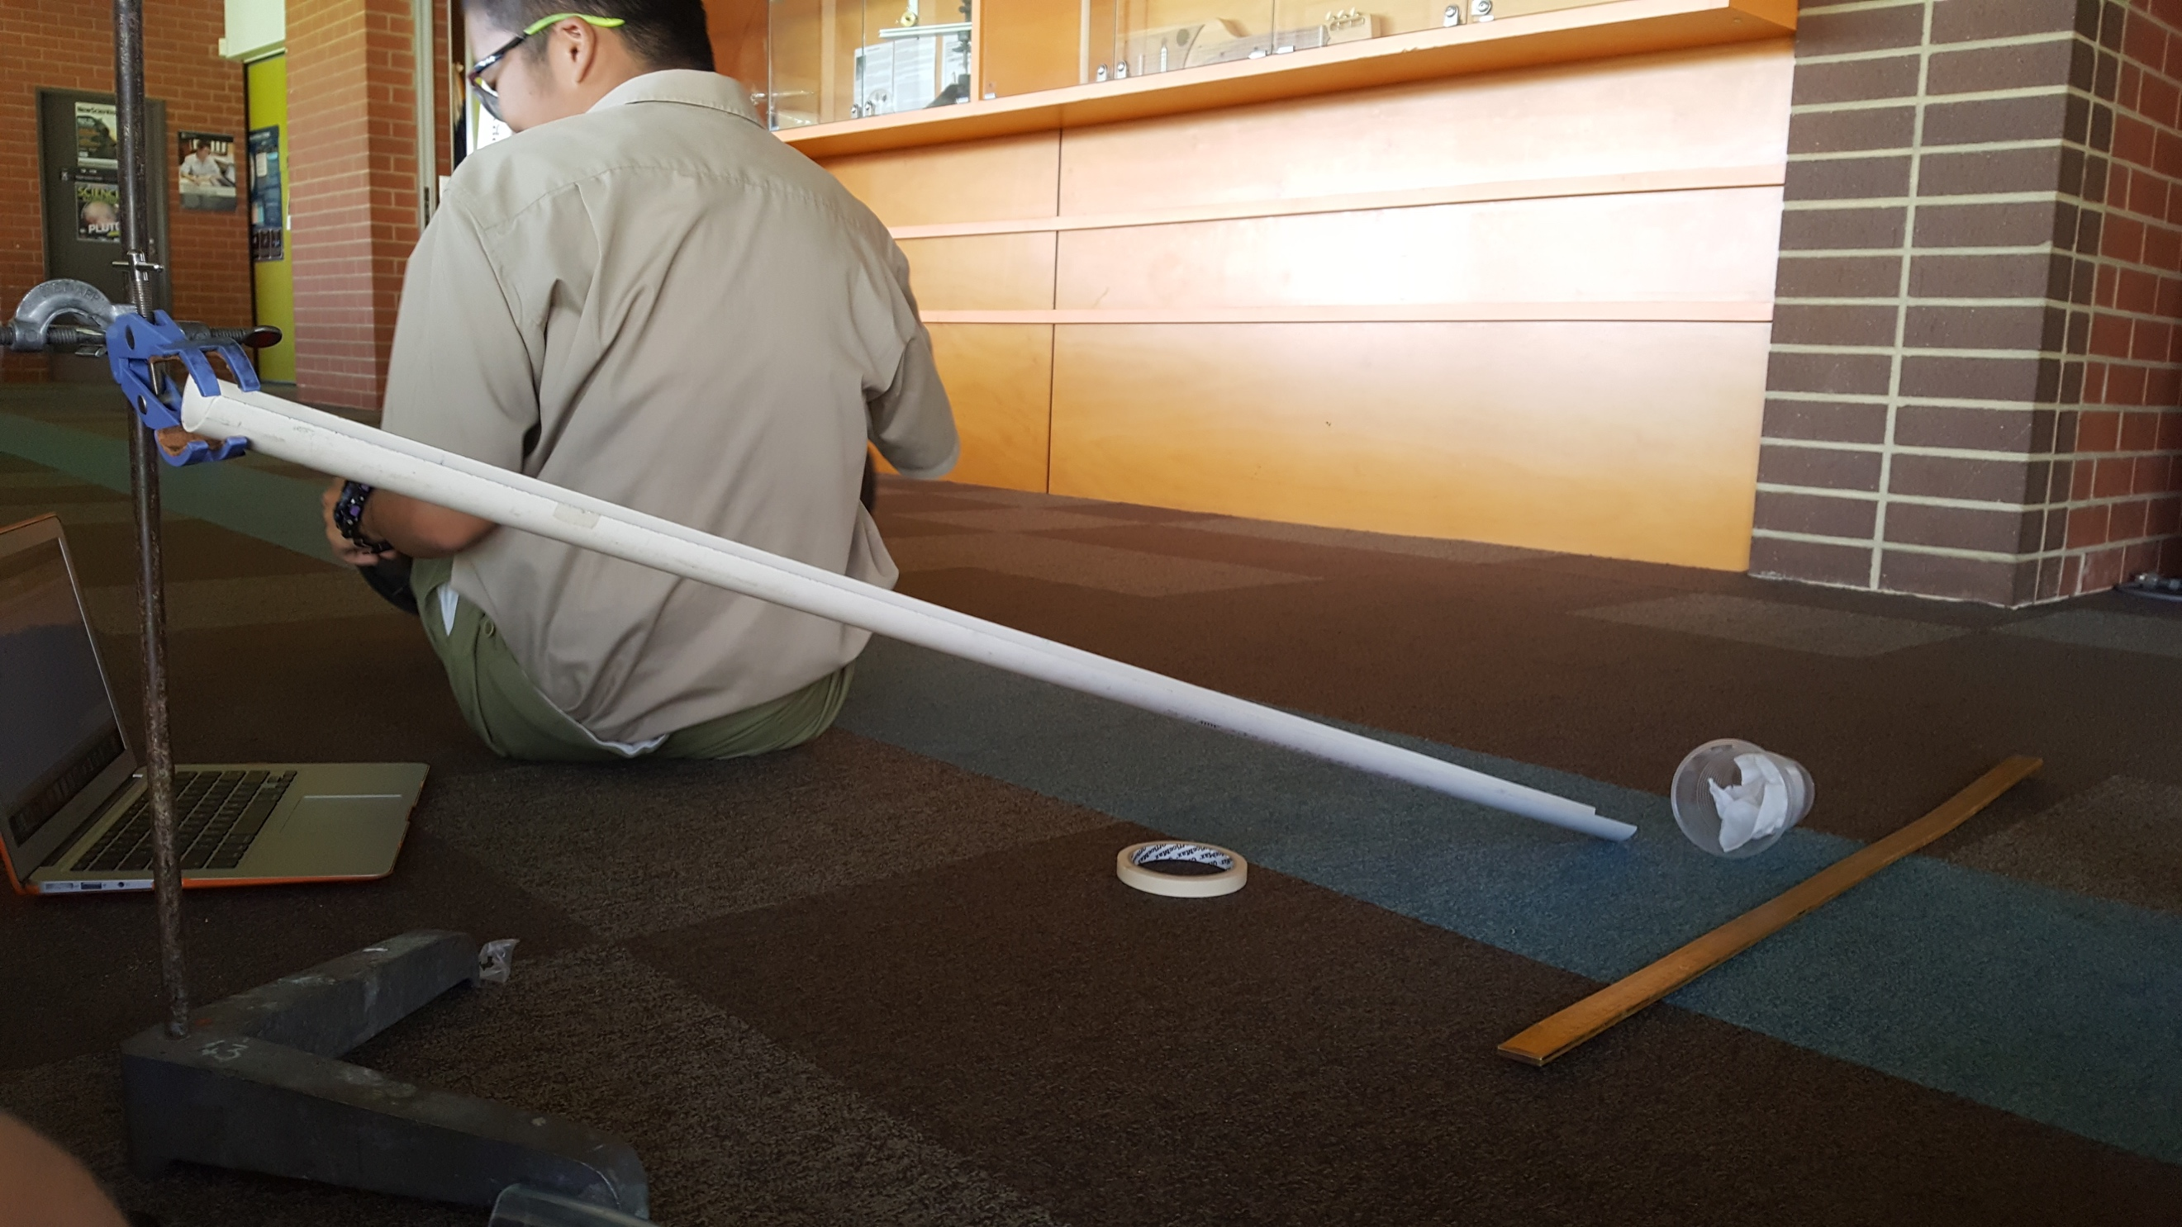

Step 2: Create a table to record data

Step 3: Set the height of the slide on the retort stand to 10cm

Step 4: Place marble at the top of the slide and let go of it.

Step 5: Record how far the cup was pushed

Step 6: Repeat step 4 and 5 five times and record the data.

Step 7: increase height of slide by 5cm and repeat steps 4, 5 and 6 again until the slide is at a height of 25cm.

## Results:

|  |  |  |  |  |  |  |
| --- | --- | --- | --- | --- | --- | --- |
| Height | Trail 1 | Trail 2 | Trail 3 | Trail 4 | Trail 5 | Average |
| 10cm | 7cm | 5cm | 8cm | 7cm | 7cm | 6.6cm |
| 15cm | 14cm | 15cm | 16cm | 18cm | 15cm | 6.8cm |
| 20cm | 20cm | 18cm | 19cm | 22cm | 25cm | 15.6cm |
| 25cm | 24cm | 29cm | 25cm | 24cm | 24cm | 20.8cm |

The results show a very consistent climb in the results as the height of the slide is increased.

## Data Processing:

I have used the mean while graphing the results. This has allowed for the results to be more accurate and reliable than if the raw data were to be used. It also simplifies the graph and allows for the viewer to more easily establish trends in the graph without having to account for outliers.

## Discussion:

The results shown in the graph show a very linear relationship between the distance the cup is pushed and the height of the slide that the marble rolls down. The trend line of the graph also represents a linear relationship between the independent and dependent variable. I do believe that if more tests were done with the slide higher the results would quickly turn into a parabola because of the angle of impact with the cup.

## Evaluation:

The results that were gathered were as consistent and as unaffected by possible variables that could cause biased variables, but some of the variables that were impossible for us to control like wind or humidity which would lead to slightly biased results. These variables were completely out of our control and there was no way for use to limit the effects I these variables.

The results from this experiment have allowed for the research question to be answered and evaluated.

The equipment that was available for the experiment was adequate but for the results to be more accurate and unbiased improved equipment would be required. One of the most important piece of equipment the measuring device would need to be improved. Instead of using a ruler the use of an electronic measuring device would greatly help measuring the results and even more importantly it would help setting up the apparatus with great precision. Also if more time was allowed for the experiments more trials and more increments in the height of the cup. This would allow for a lot more accuracy.

## Conclusion:

This experiment tested the relation between the height of the slide and the distance that the cup was pushed by the marble. This allowed for the stopping power of the cup to be tested and evaluated. The results of this test have illustrate that the higher the slide the further the cup is pushed and therefore there is a linear relation between the dependent and independent variables. These results strongly support the hypothesis in this report.